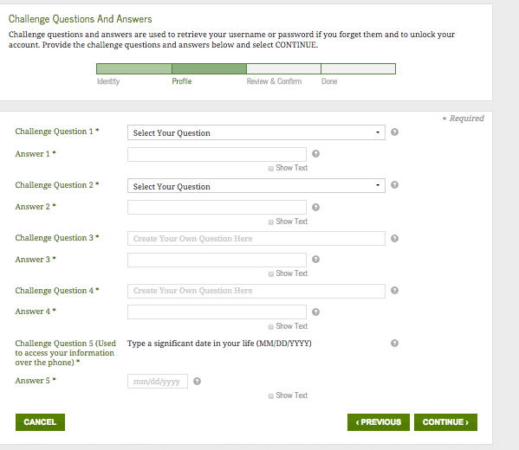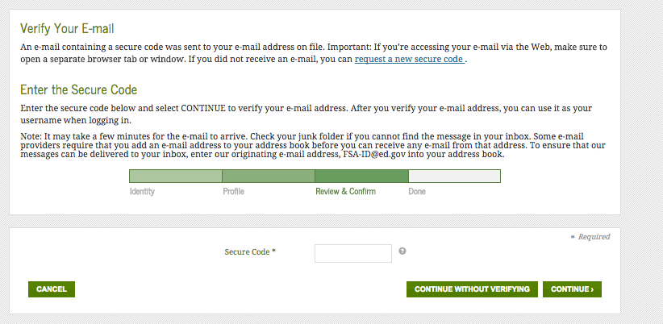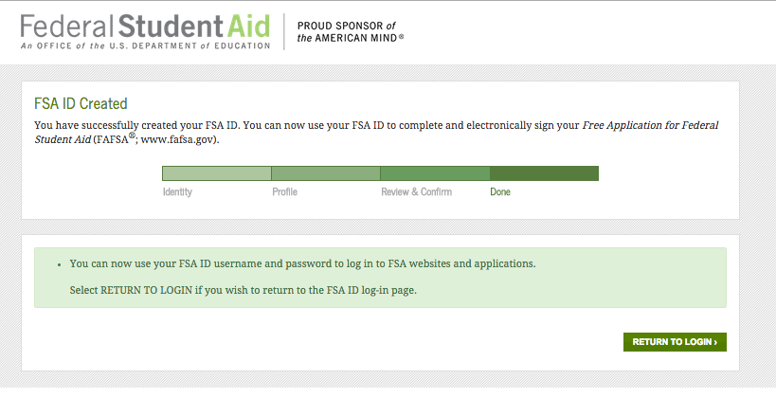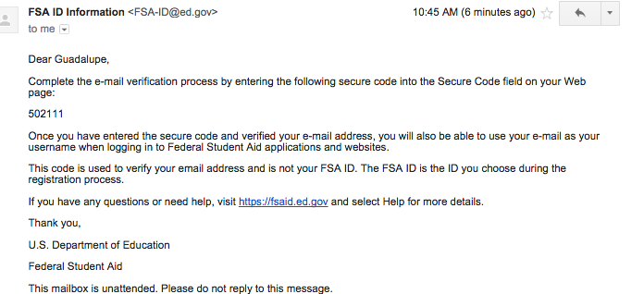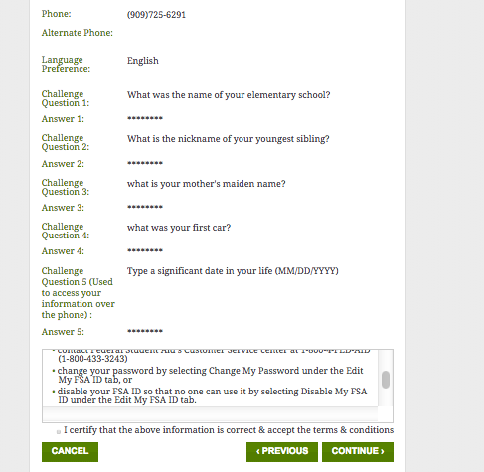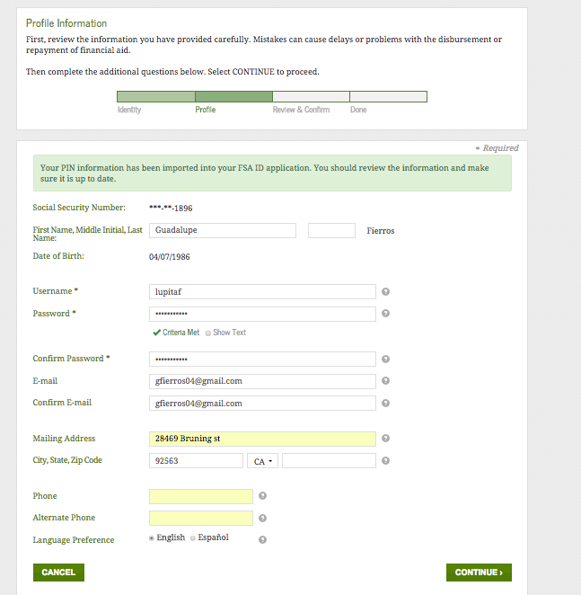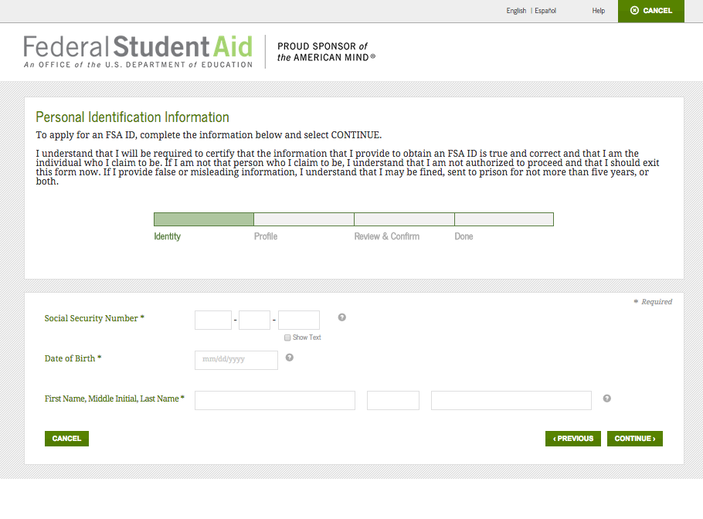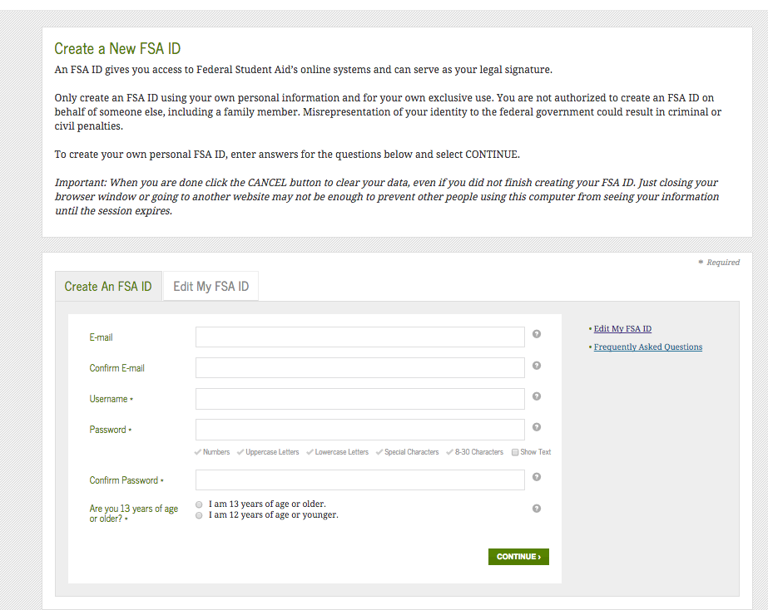

Write down your log-in information in a secure place, you will need to use it every year to apply for FAFSA.

Step 3

Choose and Create Challenge Questions

Fill-out the information

Fill-out the profile information

Step 2

Step 1

Step 6

FSA ID Created! You must return to the FAFSA website to log in.

Step 5

Verify your account: Once you confirm your account, FSA will send you an email with a secure code to verify your account.

Review Challenge Questions, read and accept the terms & conditions.

Step 4

How to Create your FSA ID