Leadership Training in the Elementary School
Table of Contents

- Introduction to the Leadership Group
- Styles of Leadership/Learning
- Helping Characteristics
- Listening and Communication Skills
- Accepting Differences and Points of View
- Assertiveness Training
- Conflict Resolution/Problem Solving
- Strategies for Encouraging Academic Success
- Closure and Evaluation
- Pre/Post Test

Leadership Nomination Form

Teacher_________________________________________________________________Grade________
It is now time to consider students for the Elementary Leadership Group. The purpose of the Leadership Group is to enhance students’ interpersonal skills and self-awareness through a variety of activities. The focus will be primarily on the styles of leadership, characteristics of an effective helper, communication skills, problem solving, conflict management, assertiveness, and strategies that promote academic success.
There will be a maximum of two nominees per classroom. For each nominee please complete the checklist below. The “Leadership Nomination Form” should then be returned to your counselor.

Student Name: ________________________________________________________________________
- Maintains average grades (A,B, or C) in ALL academic areas. ______Yes
- Exhibits exemplary school behavior (S or E).______Yes
- Exhibits satisfactory work habits. ______ Yes
- Shows evidence of leadership potential._______Yes
Briefly explain your answer:

- Please list observable strengths and/or talents the nominated student exhibits:

----------------------------------------------------------------------------------------------------------------------------------------------------------------
Student Name: ________________________________________________________________________
- Maintains average grades (A,B, or C) in ALL academic areas. ______Yes
- Exhibits exemplary school behavior (S or E).______Yes
- Exhibits satisfactory work habits. ______ Yes
- Shows evidence of leadership potential._______Yes
Briefly explain your answer:

- Please list observable strengths and/or talents the nominated student exhibits:

Session #1
Topic: Introduction to the Leadership Group
Learning Objective: Introduce selected students to the Leadership Group; to establish group rules; to define the purpose of the group.
ASCA Mindsets and Behaviors: Mindset 1; Social Skills Behavior Standard 2.
Materials
- 3-5 bean bags, balls or other objects that can be thrown or caught.
- Pencils, crayons
- Folder for each student
- Handout: Leadership “B” Rules
- Handout: Qualities of an Effective Leader

Activities
- State the basis of selection criteria for the Leadership Group:
  - Average grades
  - Exemplary school behavior
  - Satisfactory work habits
  - Show evidence of leadership potential
  - Nominated by classroom teacher
- Discuss the purpose of the group:
  - Learn more about yourself
  - Learn the skills of an effective leader
  - Develop leadership skills through activites
- Icebreaker Activity: Toss a Name Game
  - The group tosses an object in a set pattern each time, calling out group members names. More objects are added and are then passed in the same pattern. The group may set a goal for the number of objects they want to “juggle” at one time.
- Group Folders.
  - Each student receives a manila folder with his/her name on it and if time allows students may decorate their folders. All activities completed in group are to be stored in the folders and after the final meeting students can take their folders home with them.
- Discuss the Leadership B Rules
  - Review the Leadership “B” Rules handout
- Discuss the qualities of an effective leader
  - Review the Qualities of an Effective Leader handout.

Leadership “B” Rules

Be on time.
Be respectful of other’s feelings.
Be on your best behavior.
Be a good listener or speaker.
Be appropriate with language
and actions.

Qualities of an Effective Leader
An effective leader…
Is organized.
Maintains a positive attitude.
Accepts responsibility for getting things done.
Manages conflicts.
Is goal-directed.
Shows understanding.
Listens well.
Asks for opinions of others and respects others ideas and opinions.
Provides support and encouragement.
Displays self-motivation and initiative.
Is resourceful and creative.
Has well developed communication skills.
Encourages enthusiasm.
Is assertive.
Shows flexibility.
Has self-confidence.

Session #2
Topic: Styles of Leadership/Learning
Learning Objective: Students will recognize different leadership styles and develop their own style of leadership.
ASCA Mindsets and Behaviors: Mindset 5; Social Skills Behavior Standard 7.
Materials
- Group Folders
- Pencils
- Handout: Leadership Styles (1 per student)

Activities
- Review Group Rules
- Icebreaker Activity: “Everybody Up”
  - Students pair up with someone who is approximately the same size and sit on the floor facing each other. They should sit with their knees bent up and the bottoms of their feet touching each others feet. The partners should lean in and hold hands tightly and try to pull one another up at the same time. If pairs are successful, see if a group of 3 or 4 can sit in a circle with feet touching and arms grasped and pull up as a unit.
  - Process activity. What worked? What didn’t?
- Discussion of Leadership Styles.
  - Using the handout: Leadership Styles, discuss the 4 major styles of leadership: Director, Persuader, Supporter, and Thinker.
- Role Plays
  - Divide the group into pairs. Instruct each pair to develop a 2 minute skit or role play which depicts a particular Leadership Style that you assign to them.
- Review the 4 Leadership Styles
- Students should place work into their folders.

Leadership Styles
The following four basic styles represent common approaches to the role of leader. The leader of any group has both a direct and indirect effect on the team as a whole.

The Director
- Highly dominant personality
- Demanding
- Can be impatient
- Rarely will tolerate disagreements
- Acts quickly to stop possible threats to their leadership

The Persuader
- Fosters a friendly, open atmosphere
- Builds strong relationships with team members
- Uses and informal style

The Supporter
- Provides service for the team members
- Doesn’t give as many directions
- Establishes rapport with team members
- Provides support

The Thinker
- Works through planning and structure
- Respects procedure and organization
- Will wish to know the day to day happenings

*Adapted from Axiom Software Ltd. -Team Leadership Styles www.axiomsoftware.com
Session #3
Topic: Helping Characteristics
Learning Objective: Students will be able to identify characteristics of an effective helper.
ASCA Mindsets and Behaviors: Mindset 1; Social Skills Behavior Standard 7.
Materials
- Group Folders
- Pencils
- Large trash bag, dress up items, music
- Friendly Helper Game materials (1 set of directions, 1 game card, 1 set of Friendly Helper Strips, 1 paper bag)

Activities
- Review Group Rules
- Icebreaker Activity: “Musical Dress Up”
  - Ask students to sit in a circle. As the music starts, pass the bag around the circle. When the music stops, the student has 5 seconds to say something positive about him or herself or someone else in the group. If they are unable to do it, students have to reach into the bag and wear whatever they pull out. Students can be declared winners at the end of the game if they have not had to “dress up”.
  - Process activity. What was challenging about this activity? What did you learn about yourself during this activity?
- Play the Friendly Helper Game
  - Lead a discussion about what students look for in a friend, encourage everyone to participate.
  - Play the Friendly Helper Game.
  - Process the game. What skills helped your group to succeed? What was challenging about this activity?
- Review the 4 major helping characteristics.
- Students should place work into their folders.

Directions for the Friendly Helper Game

- Laminate posters with helping characteristics.
- Tape the posters around the room.
- GOAL: the entire group must work together to match the Friendly Helper Strips to the correct poster.
- One strip is pulled from the bag and read aloud. As this strip is discussed, the group decides under which characteristic it belongs. Once a decision is made they tape it to the poster.
- Review the answers at the end and make adjustments as necessary.

Friendly Helper Game Poster
CARING

Friendly Helper Game Poster
ACCEPTING

Friendly Helper Game Poster
UNDERSTANDING

Friendly Helper Game Poster
TRUSTWORTHY

Friendly Helper Strips (cut apart and place in bag or cup)
Pay attention to others
Be open to others’ ideas
Let others share
Learn about the other persons point of view
Don’t judge others
Value personal worth, don’t label others
“Tune in” to others
Summarize what others say
Express the feelings that go with any story you hear
Keep a person’s ideas private
Be a valuable key to unlocking problems and concerns
Say and do things that make others feel safe and secure

Session #4
Topic: Listening and Communication Skills (verbal and non-verbal)
Learning Objective: Students will develop skills which facilitate effective verbal and non-verbal communication between people.
ASCA Mindsets and Behaviors: Mindset 5, Social Skills Behavior Standard 1.
Materials
- Group Folders
- Pencils
- Slips of paper with song titles on them (enough for each group member to have one)
- Set of cards with prepared teaching figures
- Paper
- Handout: Reading Facial Expressions
- Set of TALK STOPPER Cards

Activities
- Review Group Rules
- Icebreaker Activity: Sing song (adapted from TLC)
  - Write the song titles below on separate slips of paper. There should be as many slips of paper as there are group members. (Row Row Row Your Boat, Happy Birthday to you)
  - Put all the slips of paper in a bowl or box and have each person draw a song title. Do not let anyone see yours.
  - After everyone has drawn a title, begin humming your song.
  - Find a partner who is humming the same song.
  - With your partner, take turns telling about something fun that happened to you. Talk for two minutes.
  - Ask your listening partner these questions: What did I say? How do you think I felt? What did you like best about my story?
  - After everyone has had a turn talking and listening, talk about the following questions with the group: What did you have to do to find a partner? What did you have to do when you were listening to your partner tell a story?
- “Teaching Figures” (adapted from Developing Human Potential)
  - Divide the group into pairs or triads. In each group one person is designated as the “teacher” and the other members are “students”. The “teacher” takes one of the Figure Cards and instructs the “students” to reproduce on a piece of paper the figure that he/she has on the card without showing the card. Only a description of what to draw and where to draw may be given.
  - The “teacher” may see the “students” work but the “students” may not talk to the “teacher”.
  - Variation: The “teacher” may not see the “students” work but the “students” may ask questions.
  - Following each try the “students” work is compared to the card.
  - Process this activity by discussing the importance of oral and visual feedback and the need to define terms clearly and identify reference points.
Review the 4 major helping characteristics.
- Students should place work into their folders.

Reading Facial Expressions:
A leader must know how to read faces. Directions: For each picture, answer these questions:
Would you speak to the person? If yes, what would you say? If no, why won’t you speak?
1
2
3
4
5
6
7

Session #5

Activity: Accepting Differences/Points of View
Grade(s):4th-5th
ASCA Mindsets & Behaviors (Domain/Standard):
Mindset 1; Behavior Standard Social Skills4; Behavior Standard Social Skills 7

Learning Objective(s):
1. Allow students to understand various points of view exist in every situation.
2. To broaden tolerance and acceptance of difference in people and their points of view.

Materials:
Different Points of View Worksheet
Walking the Line Worksheet
Masking tape

Procedure
1. Review any pertinent Group Rules

2. Icebreaker: Different Points of View
This activity was taken from the book Leadership a Skills Training Program, and its purpose is to understand the viewpoints of many different people. Follow the directions on the sheet and then process the activity.

3. Activity #1Walking the Line.
A. This activity is from the book Appreciating Differences and its purpose is to teach students to be more sensitive to and respectful of others.
Follow the enclosed directions for the activity. Then process through.

Different Points of View
A leader must be able to understand the viewpoints of many people
Directions: Select 1-2 situations read aloud and discuss.
- The snow is failing, light lovely and deep.
What would you think about this if you were:
-a snowflake falling to the ground? -a salesperson for snow shovels?
-a small child, 5 years old? -a person driving to work?

- Vacation for the summer will soon be over.
What would you think about this if you were:
-a student going back to school? -a mother in the home?
-a teacher? -a park attendant?
-a mother daily goes to work outside the home?

- A wrist watch is not keep good time
How would you feel about this if you were:
-the person who owned the watch? -a watch repair person?
-salesperson who sells watches?

- The sun is hot, very hot. It will be very hot all day
What difference would this make to:
-the person selling ice cream? -lifeguard at the swimming pool?
-police officer walking the streets? -mail carrier?
-a very small baby? -an elderly person?

- Bobby cannot count to 100. He is in the second grade.
What would you think about this if you were:
-Bobby? -Bobby’s teacher?
-Bobby’s parents? -Bobby’s friends?
-Bobby’s little sister?

- A holiday is approaching. You and your family are going on a trip. You suddenly get sick. You cannot go on the trip. The family decides that the trip must be cancelled for everyone.
How would you feel about this if you were:
-the one who is sick? -another member of the family?
-the doctor? -travel agent?
-the pet dog?
Discuss: Why did you feel different for each person or thing even though it was the same situation? Do you think people feel differently about the same situation?

Walking the Line

Directions:
- Line up students in a single file line in the middles of the classroom on a strip of making tape.
- Call out each situation.
- If the situation called out applies to the student, then he/she should take on large step forward and turn to the face the people standing on the line.
- Once the group has been identified, ask the following questions:
  - How do you think the others feel about you?
  - How do you feel about yourself?
  - How do you feel about others like yourself?
- Once the group has covered the situations, discuss how this activity has or has not changed their perception and opinions.

WALKING THE LINE Situation list
Step out from the line if you…..
Have a brother or sister
Like School
Live with both your mom and dad
Live with your mom only
Live with your dad only
Live with others
Know someone personally who recently died
Have cried in the last month
Have lied to a parent or teacher
Aare a mixed race
Have said a racial slur
Live with someone who is disabled
Speak another language at home
Celebrate Christmas
Have cheated on schoolwork

****These situation must be considered carefully. They do draw out difference, but if they seem too volatile or offensive, substitute others.

Session #6

Activity: Assertiveness Training
Grade(s):4th-5th
ASCA Mindsets & Behaviors (Domain/Standard):
Behavior Standards Social Skills 1; Behavior Standards Social Skills 8

Learning Objective(s)
1.To learn various ways a person communicates.
2. Understand the various ways to communicate assertiveness though feelings, needs and wants.

Materials
Icebreaker: Getting Along Take from TLC: Tutoring, Leading, Cooperating: Training Activities for Elementary Students.
Materials for Activity #1: Handout “ Types of Communication”
Materials for Activity #2: Role Play Hints cards and set of role plays

Procedure
1. Review any pertinent Group Rules

2. Icebreaker: Getting Along

3. Activity #1 Using the Types of Communication handout, teach students the differences between the different types.
A. Aggressive responses and behaviors (Tiger)
B. Passive responses and behaviors (Turtle)
C. Assertive responses and behaviors (Owl)

4. Activity #2 Role Plays
A. Discuss with the students the “Role Play Hints” card
B. Students divide into teams of 2.
C. Each team takes a card and creates a role play form the stated situation.
D. After each role play, process by discussion why the assertive response is better.

5. Verbally review the concepts of aggressive, passive and assertive responses.

6. Students should placer al work in their folder.

Getting Along
Purpose: To practice working with people who are not cooperative.
Materials: None
Procedure:
- With your class, divide into groups of five. One person will be the leader, one person the secret disturbed and the other three will be themselves.
- Choose a leader form your group of five.
- Your teacher will choose a kind of distributer from the list that follows and whisper it in the ear of one of the other four group member. Your teacher will whisper it in the ear of one of the other group members. Your teacher will whisper “be yourself” to other three group members.
- The leader begins by telling the group that the topic for discussion is whether or not you need homework.
- Your group will have five minutes to talk about this topic.
- During these five minutes, the secret disturber should act out his or her role. For example, if the distributer was told to be the arguer, he or she should argue with their other group members. If the distruster is shy and quiet he or she should look down and talk in whispers or not at all. The leader and other group members would try to help the disturber to become more cooperative in the group discussion.
- At the end of 5 minutes, discuss the following questions with the group
- In your small groups, change leaders and to the activity again using a new distributer from the list.
  - What was it like to have a distributer in the group? Why does this kind of behavior disturb the group?
  - How did your group react to the disturber?
  - What did the leader do?
  - What did group members do?
  - Are there other group distributers that need to be added to this list?

Disturber List

The Arguers-These people will argue with anyone about anything. Sometimes they are loud about it or angry. Often they want everyone to see that they are right.
The Talkers-These people talk too much. Sometimes they just talk on and on. Other times they answer all the questions or interrupt when others are talking.
The Put Downers-These people make others feel bad. They laugh at things other people say or they call them stupid or dumb. Sometimes they say “shut up” or make ugly faces.
The Shy and Quiets- These people never say anything. You might think they would not disturb anyone. But, in a group, shy and quiet have everyone worried about them. Some groups spend so much time trying to be sure the shy and quiet are not left out they don’t get anything else done.
The Wigglers-These people are always doing something other than what the group is doing. They clean out their notebooks, look at the clock, or wiggle around in their seats. It’s hard for others to pay attention with a wiggler around.

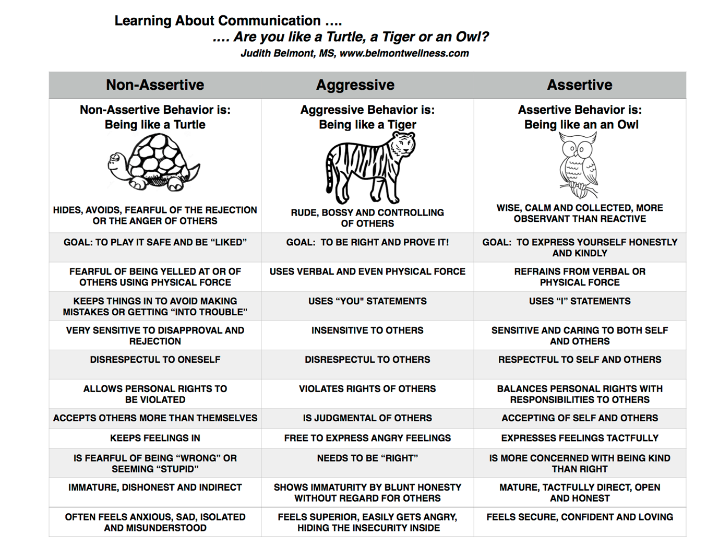

Role Plays

Each role play needs a beginning middle and end. Students need to come up with 3 role plays each illustrating the different type of communication. Aggressive, assertive and passive.

Today you brought your lunch to school and had a piece of chocolate cake in it. The person sitting besides you says, “Hey let me have your cake!! Give it to me! Please! Please!” They continue to beg.

You go to McDonalds with a friend and order a milkshake and French fries. You pay for them and go to sit down. Then you discover that your bag ONLY has a milkshake in it. No fries.

A friend borrows a video game from you, promising to take good care of it. When the video game is returned, it is broken.

Session #7

Activity: Conflict Resolution & Problem Solving
Grade(s):4th-5th
ASCA Mindsets & Behaviors (Domain/Standard):
Behavior Standard Social Skills 5, Behavior Standard Social Skills 7

Learning Objective(s)
To learn and practice effective decision making and problem solving skills.

Materials:
Colorado Education Initiative Decision Making Sheet
Colorado Education Initiative “The Model”
Snack Time, Meal Time, Decision Time Sheet

Procedure
1. Review any pertinent Group Rules

2. Icebreaker:

3. Activity #1 Steps to Making a Decision
A. Using the Colorado Education Initiative, discus each step in the decision-making process.
B. Read the enclosed story. “Snack Time, Meal time, Decision time.
Use the decision making model taught above to help the character, Mrs. Caldwell make the best decision possible.

The Model: (1) Identify Decision (2) Brainstorm Options (3)Need Help? (4)Make Decision
(5)Describe Outcome

The Steps

Skill Steps | Teaching progression | Grades 3-5 Decision Making Example:
Step 1: Identify the Situation That Needs a Decision | Students identify a list of situations where a decision needs to be made.  - Explain that decisions are made based on a variety of factors, experience, knowledge, and emotions.  - Some decisions need to be made prior to the situation. For example, the decision to not use tobacco needs to be made before you are offered to use it.  - Important decisions should be made in a thoughtful way. | A couple of my friends don’t want to include Jenny in our recess game. I am friends with Jenny, but also want to play the game with my other friends. What should I do?  I think this is a situation that I need to make a decision about before recess.
Step 2: Brainstorm Options and Predict and List Positive and Negative Outcome | Students make a list of all of the possible options they would consider for a situation. The use of a chart is beneficial in listing all of the positive and negative outcomes of each option. The following questions may help guide students thinking:  - Is the option healthy or unhealthy?  - How does this option affect me?  - How does this option affect others? | My options are to:  - I could ask my friends if Jenny could play. Outcomes, positive, I get to play with all of my friends, Jenny doesn’t feel left out, negative, my friends might get mad at me, my friends might day no.  - I could play with Jenny by myself. Outcomes: positive, I get to play with Jenny, Jenny isn’t left alone, negative, I don’t get to play the game, my friends might get mad at me.
Step 3: Analyze the Possibility of Needing Assistance | After identifying options and outcomes, students distinguish between the decisions they can make by themselves, and the decisions with which they need help.  Consider the following questions:  - Are you having trouble coming up with healthy options?  - Is your safety or someone else’s safety at risk?  - Are you feeling uncomfortable with your options?  Based on the answer to these questions, do I need to ask a trusted adult or refer to another resource for help? | I feel safe in this situation, and comfortable with the healthy options that I have. I can make this decision on my own.
Step 4: Make a  Decision and Follow Through | Students are now ready to make a decision based on their analysis of the positive and negative outcomes. | I will choose the option that is the healthiest for me, and follow through with the decision to find other friends that we can both play with.
Step  5: Describe the Outcome of the Decision | Students will describe the outcome of their decision and determine if the outcome was positive or negative for others and myself. | I told my teacher what I did and what happened. The outcome was positive because Jenny and I both had fun at recess.

Colorado Education Initiative coloradoedinitiative.org
Health Skills Models: www.rmc.org/healthskills

Decision-Making Worksheet
Directions: Read the decision-making situation and complete the decision-making steps below.

Step 1 - Identify the Situation:

Step 2 - Brainstorm Options and Predict and List Positive and Negative Outcomes:

Option | Positive Outcome | Negative Outcome

Step 3 - Analyze the Possibility of Needing Assistance:

Answer the following questions:

1. Are you having trouble coming up with healthy options? | Yes | No
2. Is your safety or someone else’s safety at risk? | Yes | No
3. Are you feeling uncomfortable with your options? | Yes | No

If you answered yes to any of the questions above, seek the help of a trusted adult or resource. Who is a trusted adult for this decision?

Step 4 - Make a Decision and Follow Through
Make the decision that is best for you and record it below.

Step 5 - Describe the Outcome of the Decision

After you have followed through with the option you chose, describe the outcomes below.

Snack Time, meal Time Decision Time

Mrs. Caldwell is a kind lady of eighty something years. She lives in a neat little house that is just right for her. Mrs. Caldwell is a lady of habit. Her daily routine is always the same.
Each morning she arises at six o’clock. She has a piece of toast, two slices of bacon, a bowl of hot cereal, a glass of fruit juice and one hot cup of coffee for breakfast.
Once the dishes are cleared, Mrs. Caldwell sits where she can watch boys and girls pass by on their way to school. She has a friendly wave and a big grin for each boy and girl.
Having rested, Mrs. Caldwell cleans her house, takes a bath, and then lays down for a brief nap.
After lunch, Mrs. Caldwell makes a daily batch of cookies. Each afternoon she shares her cookies with boys and girls who stop by to see her. For Mrs. Caldwell, this is the high point of her day. She says “talking to youngsters does me a world of good. As long as I can talk and be happy with these youngsters, I will remain young.”
When the cookie snack is over, Mrs. Caldwell again rests for a while.
When she arises, Mrs. Caldwell cooks her evening meal. She always has a small salad or bowl of fruit, a serving of meat, a vegetable and class of milk.
From Monday through Friday Mrs. Caldwell follows this schedule.
On Saturday, Mrs. Caldwell’s daughter pickers her up. They got to the daughters house for breakfast. Then they go to Mrs. Caldwell’s doctor to have her blood checked. Mrs. Caldwell must do this each week because she is suffering from high blood pressure.
After leaving the doctor’s office, Mrs. Caldwell goes to the drug store for her medicine for the next week, and then spends the rest of Saturday at her daughter’s house returning home just in time for bed.
On Sunday, she spends the entire day with her younger brother.
This week Mrs. Caldwell is faced with a problem. Her blood pressure is up and the doctor has changed her medicine. When she went to the drug store to get her new medicine it cost twice as much as before.
Mrs. Caldwell has a fixed income. She gets a small check each month. This amount is always the same. It does not change from month to month.
In addition, she has a small savings account, which she is saving for serious emergencies. Mrs. Caldwell does not receive enough each month to pay for the new medicine. In order to pay for the medicine she would have to change her daily habits.
Mrs. Caldwell doesn’t know what to do. She tells her daughter “I don’t see how I’ll pay for the new medicines. My wants are simple. They have not changes. But now I am no longer able to the simplest things I want to do.
Her daughter replied “I’ll help you, mother. Why don’t I give you a small allowance each week?”
Mrs. Caldwell wanted to cry. She wasn’t a child and she didn’t want an allowance. She tried to remember that her daughter just wanted to help, but she was mad at her daughter. She wanted to be independent and this meant she wanted to spend her own money and make her own decisions.
Later Mrs. Caldwell called her brother.
Her brother said “I’ll give you a small check each month”
Mrs. Caldwell said “No thank you! She slammed the telephone down angry with her brother.
Mrs. Caldwell tried to think of some other answer. She wanted to make a decision that would make her least unhappy.
She said “I might stop having snack time for the children. The money spend on cookies would pay for my new medicine. But this is my very favorite time of the day.
I might stop drinking milk. The price of milk would pay for my new medicine, but I need to drink milk too.
Mrs. Caldwell thought and though she was worried and angry. She believed something ought to be done something that would be fair.
Finally Mrs. Caldwell made the best decision she could possible make. Imagine you are Mrs. Caldwell and complete the decision making sheet.

Decide on some alternatives and come up with best decision with the group.

Process: How did you arrive at your decision? Was it easy for everyone to agree? What made it difficult to come to a decision? Could there be several options that all make a good decision?
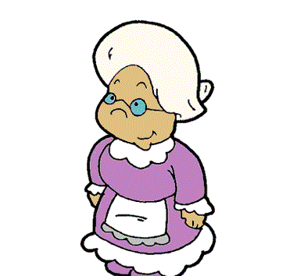

Session #8

Activity: Strategies for Encouraging Academic Success
Grade(s):4th-5th
ASCA Mindsets & Behaviors (Domain/Standard):
Mindset 6, Behavior Standard Self Management 3

Learning Objective(s) (aligns with Competency):
1. To learn and utilize several strategies which promote academic success in self and others.
2. To prepare students with strategies which will be used for tutoring younger students.

Materials
Brain Teaser worksheet
Picture Walk Technique worksheet
Reading Strategies worksheet
Folding In Technique

Procedure
1. Review any pertinent Group Rules
2. Icebreaker: Brain Teasers
See how many your students can figure out.

3. Activity #1
Teach peer leaders how to work with younger children using the Picture Walk Technique. Collaborate with the Reading Specialist at your school if you have one available to help teach this technique.

4.Activity #2
Briefly go over reading strategies with the students. They will be using these when working with younger students. Make a copy to keep in the folder as a reference.

5. Activity #3
Teach peer leaders how to do the folding in technique while using flash cards.

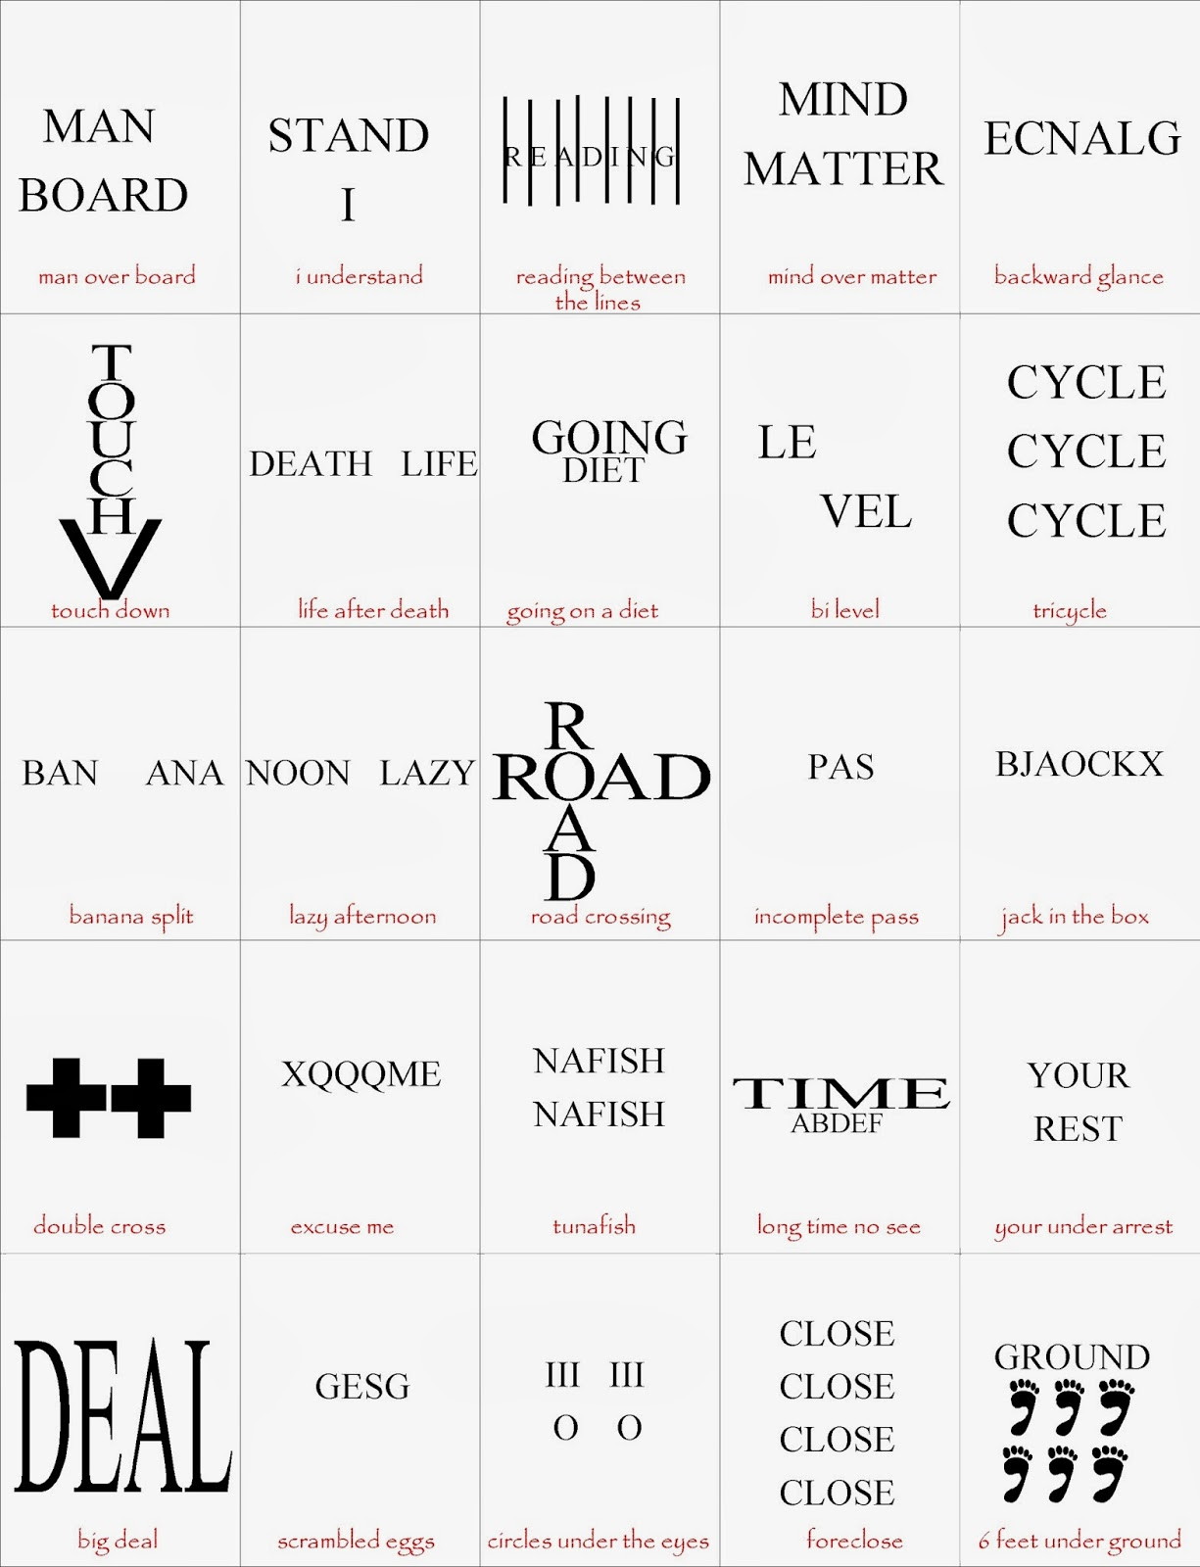
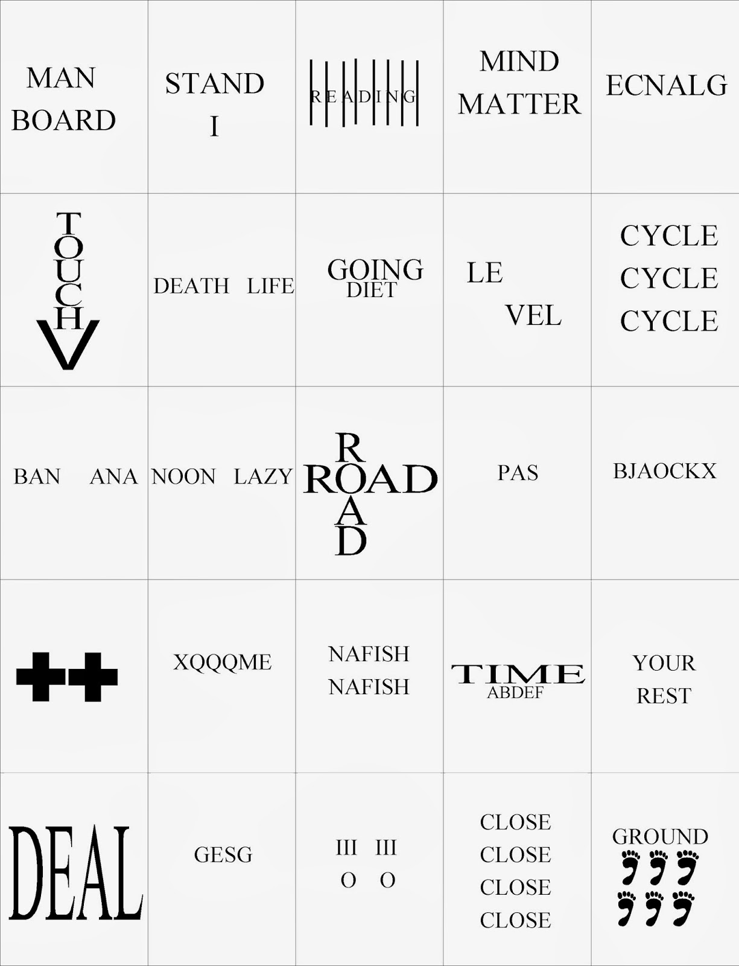
The "Picture Walk"
Last updated Tuesday, March 19, 2002
We are generally curious beings. If we see something intriguing, we want to try to understand it. If we hear an unusual noise, we wonder where it came from. Children can be especially curious, since each day brings them new experiences and new questions to be answered.
In preparing children for a read-aloud session, you can stimulate their natural curiosity and pique their interest in a story by going through a "picture walk." Before opening the book, show the children the cover and read the title. Ask them what they think the story will be about, based only on what they see.
Then slowly flip through the book, page by page, without reading a single word. Ask them questions about each picture they see, and try to elicit responses that require them to make inferences based upon the images, and not the words, on each page.
"What is going on here?" "Who is this?" "Why does the character look so excited?" "When is this story taking place?" "Where did the character just come from?" "How do you think the story is going to end?"
Starting with the five "W" and one "H" question words, you will be able to ask plenty of questions that will engage the students' imaginations and encourage their active participation. Vague responses that don't give away your knowledge of the storyline, such as "That's very possible!" or "Are you sure about that?" will plant seeds for enthusiastic discussion while you're actually reading the book. The students will be excited to find that outcomes they have predicted are correct, or they will be surprised to find that the plot has taken some unexpected turns.
Once you're done with the "picture walk" and have started the actual read-aloud session, short discussions while you're reading can be very beneficial to the children because they reinforce the critical thinking that you fueled by stimulating their curiosity during the "picture walk."
Some good topics for discussion include a testing of their storyline hypotheses ("Do you still think the story is going to end like that? Why or why not?"), an appraisal of the characters' actions ("Was it a good idea for the character to do that? How would you have solved that problem?"), and an examination of cause-and-effect relationships ("So now that you know what really happened, why do you think the character looks so excited?").
It is helpful to moderate these discussions in a way that maintains the smooth flow of the story and ensures that the students comprehend the story's key points. Also, it is important that the children feel the freedom not to participate verbally if they so wish. The less confident children may want only to listen at this stage, and for them, it is important to gauge their attention to be sure they are at least mentally engaged in the discussion.
The "picture walk" can serve as a powerful tool to stir some interest in both the story and in the read-aloud session. Not only can it encourage the children's participation in group discussion, but it can also improve their comprehension of the story. Providing them with a tantalizing glimpse of visual story elements should help stir their imaginations and help them weave an intellectual frame of reference for better organizing and evaluating what they hear as you read the actual story.

http://readingtokids.org/ReadingClubs/TipPictureWalk.php

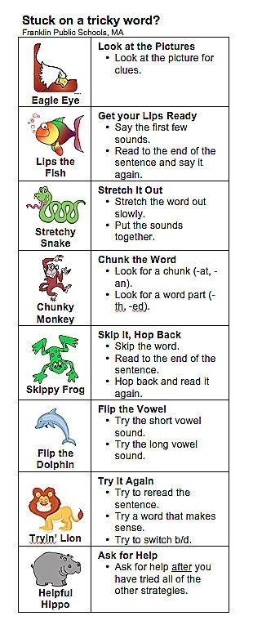

Flash Card Folding In Technique

Procedure. Below are the steps the student follows in each session to implement the math-fact self-administered
folding-in technique. (NOTE: Because the student is the interventionist, the steps are written as student directions):
1. Start with the daily stack of cards from the last session. Or create a new "daily stack" by taking 7 cards from your weekly "known" stack and 3 cards from your weekly "unknown" stack and shuffling them.
2. Take the first card from the top of the daily stack and place it flat on the table.
3. Read the math-fact on the card and write the answer on the dry-erase board within 3 seconds.
4. Turn the card over and compare the answer that you wrote to the answer on the card.
5. If your answer is correct, sort that card into a "daily known" pile. If your answer is incorrect, sort that card into a"daily unknown" pile--then practice by writing the math-fact and correct answer on your dry-erase board three times in a row.
6. Continue until you have answered all 10 daily cards. Then look at the daily "known" and "unknown" card stacks.
If all daily cards are in the "known" stack, draw a star in the bottom left corner of your dry-erase board.
7. Shuffle the 10 cards in the daily card deck.
8. Continue reviewing all 10 cards in the daily deck as explained in steps 2-7 until you have drawn three stars in the bottom left corner of the dry-erase board. (In other words, continue until you have answered all 10 cards without
error in a single run-through and have accomplished this feat a total of three times in the session.)
9. When you have earned 3 stars, consider the entire daily stack to be "known" cards. So it's now time to update the daily deck.
10. Take any 3 cards from your current daily 10-card deck and transfer them to the weekly "known" deck.
11. Next, take 3 cards from the weekly "unknown" stack and add them to your current daily deck to bring it back up to 10 cards.
12. Begin reviewing the daily stack again (as outlined in steps 2-7) until your time runs out.
13. Before ending the session, place rubber-bands around the weekly "known" and "unknown" decks and the daily stack that you are currently working on.

http://www.interventioncentral.org/sites/default/files/pdfs/pdfs_blog/self_management_math_SAFI.pdf

Session #9

Activity: Group Closure
Grade(s):4th-5th
ASCA Mindsets & Behaviors (Domain/Standard):
Mindset 5, Behavior Standard Social Skills 7

Learning Objective(s)
1. To verbally review the essential skilled learned in the Leadership group.
2. To solicit feedback from students.
3. To allow for time to process Leadership group coming to an end.

Materials:
Well inflated beach ball
Coat of Arms worksheet
Student evaluation
Post test

Procedure
1. Review any pertinent Group Rules

2. Icebreaker:
Throw the beach ball to one another, including everyone. Students answer questions: favorite leader, who inspires them, their favorite teacher and why..etc
Leader can pre write questions on beach ball and have student answer the question their right hand is touching.

3. Activity #1: My Coat of Arms
A. Using the handout, students will complete the “Coat of Arms.
B. Process students completed work. Have each share one or two ideas from their page.

4. Activity #2 Evaluation-Students will complete and evaluation of the Leadership group

5. Activity #3 Students will complete post test

6. Students will be given their folders to take home.
Instructions: On the “Coat of Arms” use WORDS or draw PICTURS or SYMBOLS in response to the following numbered open sentences.
- For the next year, the MOTTO I’m going to live by is…
- My greatest strength as a leader will be..
- The leadership weakness I most want to improve is…
- A leadership goal I will set for myself is…
- A leadership goal I will set for myself is…
- What I learned the most from this training.
- On the banner….My name is.

STUDENT EVALUATION
Elementary Leadership Group
Session #9

Students Name___________________________________________________________________

Date________________________

Please answer honestly.

What do you think the purpose of the Leadership group has been?

Do you feel that this purpose has been accomplished?

What have you enjoyed MOST about this group?

What skill that you have learned has been the most valuable?

Rate this Leadership group experience.

1 2 3 4 5
Poor Okay Excellent

List below any suggestions you have to improve Leadership training for elementary school students.

Pre/Post Test
Peer Leader Program
- What are 5 qualities of an effective leader?

- If someone is a leading a group in the DIRECTOR style, what are 2 things they may be doing or saying?

- What are the 4 major helping characteristics?

- What are some 3 examples of ASSERTIVE behaviors or statements?

- What are 2 strategies you can use when working with a struggling reader?

Teaching Figure #3

Teaching Figure #1
Teaching Figure #2

