Pinacate 7th graders conducted research and created a PowerPoint they presented to their peers on :

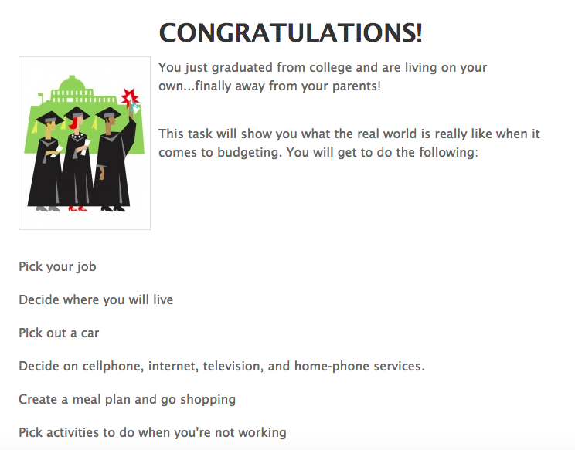
Students used this information to input into a budget spreadsheet to evaluate their expenses vs. income.

* It was great to see many students re-evaluating their college and career choices once they discovered they wanted to live a certain life style.

Lesson was put together by Ms. Mckenzie, Mrs. Crouse and myself.

All 7th grade teachers were given all materials for the lesson and trained on how to teach the lesson prior to the College Day.

