**ROBERTS ELEMENTARY KIDS TO COLLEGE PROGRAM**

1. **College Aspirations-Create a College Going Culture**

* Signs

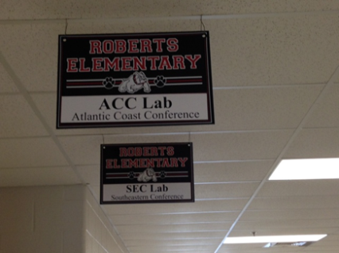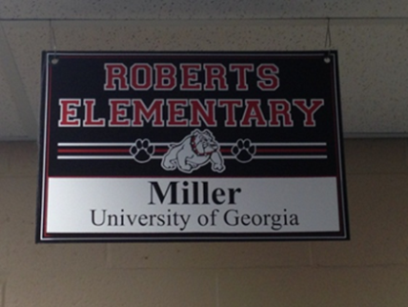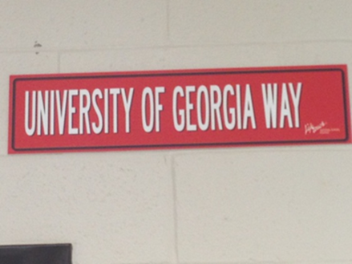

* Future College Graduate Sign with 5th grade Pictures

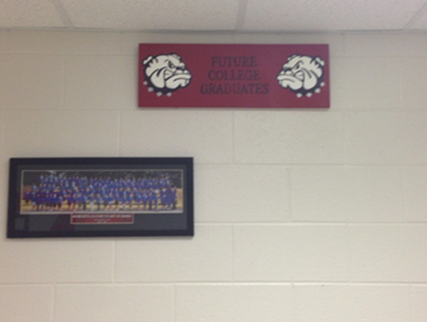

* Ceiling Tiles

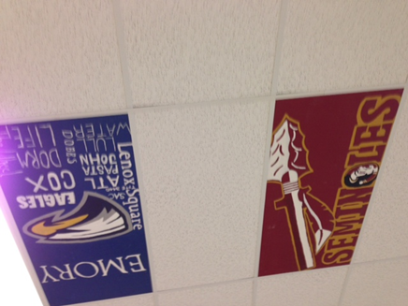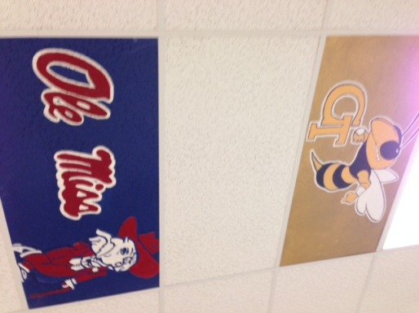

* Mascot Stickers

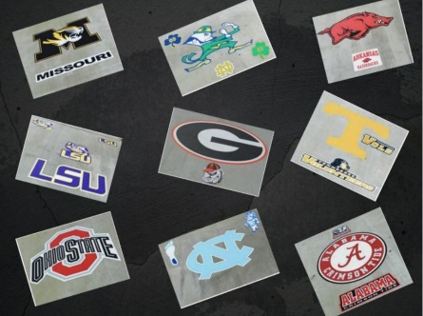

* Character Ed Program- Achiever Beaver (College is for You!!)

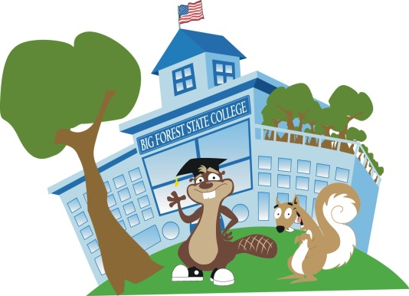

* Daily Learners Creed
* I believe in myself and my ability to do my best at all times.
* For today –
  + I will listen.
  + I will think.
  + I will speak.
  + I will reason.
  + I will read.
  + I will write.

I will do all these things with one purpose in mind, to prepare myself for college, to do my best and not waste this day, for this day will come no more.

* College Corner

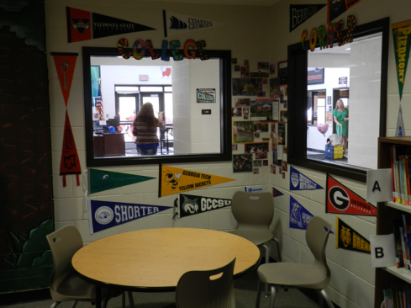

* Word Wall

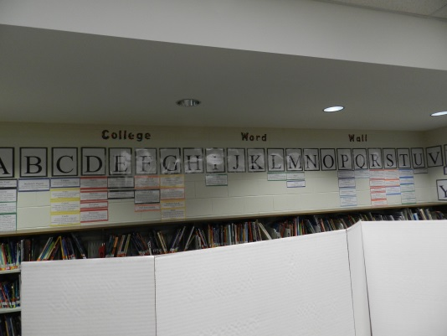

* Door Decorating Contest

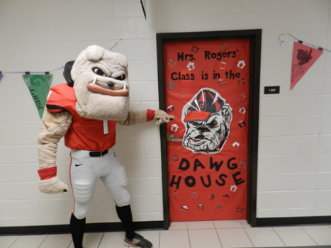

* Dogs representing Colleges
* Classrooms

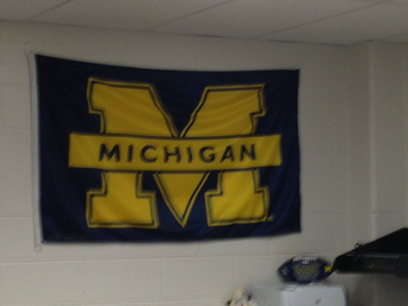

* Spirit wear on Fridays w Jeans
* ABC Report-Monitor the kids most at need
* Watching for Special Ed placement
* Eliminate Retention and advocate for a strong RTI program

1. **Academic Planning for College and Career**

* Examine the schools data and who is the gifted program, reading scores
* Advocate for kids to be tested for the gifted program
* Meet with the MS for appropriate placement for the rising 6th graders
* Staff development on Relationships
* Incorporating vocabulary words into lessons and instructing teachers the gap on ED students

1. **Enrichment & Extracurricular Activities**

* Examine Data on who is in the higher classes
* Leadership Programs: Peer Leaders, Rex Readers, Bulldog Buddies, No Name Calling,
* 14 Clubs( GOTR, Boys Running Club, Robotics, Readers Rally)
* Examine transportation and fee issues with clubs and activities

1. **College and Career Exploration & Selection**

* College of the Week

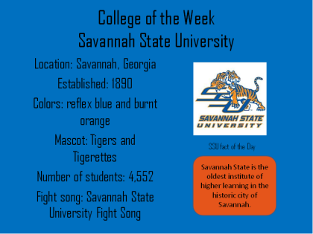

* Announcements from the College of the Week

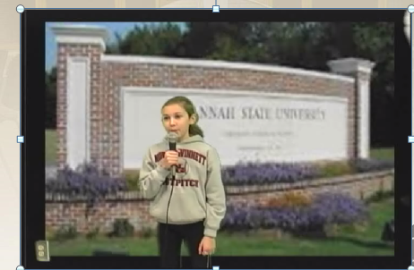

* Career Cluster Signs

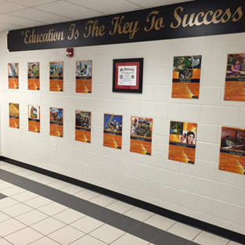

* Bulletin Board and Daily Trivia w prizes

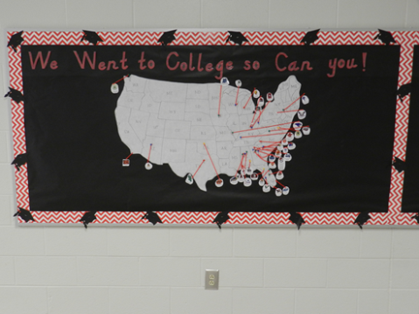

* College Celebrity Boards w year and major

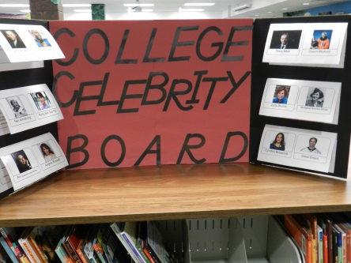

* College Kick off Speaker

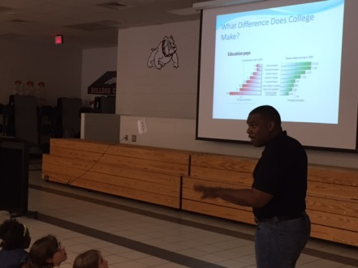

* College Packet Research w Pennant
* College Field Trip
* Rex Rules Q & A
* 17 Career Clusters Lessons
* College & Career Day (5 rooms divided up by degrees and clusters)

1. **College and Career Assessments**

* 4th and 5th grade assessments on colors and career inventories
* Anxiety Groups
* Lessons on Behavior and Mindsets especially anxiety

1. **College Affordability Planning**

* College Planning Institute Speaker
* College Fund for students each month
* Lessons on scholarships and financial savings